Time Clock Requirements Document

Samples screens given in this document are for illustration only. Please make the screens look better than these

These are the requirements for a simple time clock app.
- Database will be a simple CSV file.
- PHP language
- The interface must be fully responsive for all screen sizes.
- All keyed USERIDS should be forced to lowercase and carried in database in lower case, so we do not have case-sensitive issues
- USERID will be email address and PASSWORD is simple 4 digit numeric password.
- There should be three levels of security
  - Admin
  - Manager
  - Employee
- Need ability to log out with an auto logout in 120 seconds for Admin and Managers users (not for Admins)
- All TIME-OF-DAYS will be carried in military time (24 clock) on GUI and in the database
- Time calculations must cross from one day to the next accurately. (e.g., overnight shifts like 22:00–06:00).
- Admin can access the system from any IP (no validation for Admins)
- Manger & Employee has up to 5 IP addresses through which they can access the system. If a Manger or Employee is not at one of their designated IP’s they are denied entry.
- Admin can access the system form any IP
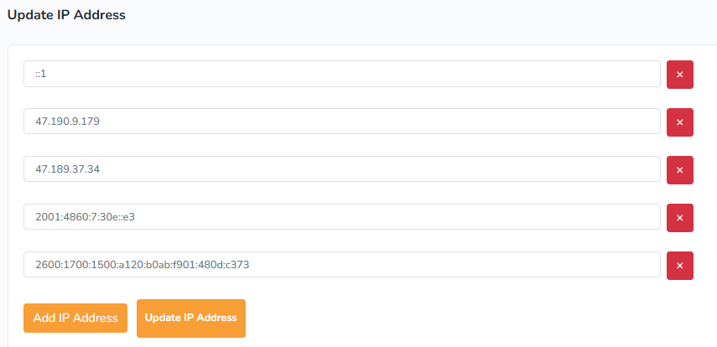
- Each person using this system will have a unique password and a control panel. Admins can Add/Update/Delete the following:
- The five allowed IP addresses for system access.
- The scheduled hours in which the user must clock in and clock out.
- Clock-in window: Each day has a CLOCKIN-FROM and CLOCKIN-TO time. The user must clock in within this window. If they attempt to clock in outside the window, block the clock-in and show a message that they are late and cannot work that day. Only their manager can override this and manually clock them in
- The default CLOCKOUT time. This default is replaced when the user clocks out manually before the default time. They cannot clock out after the default time.
- Each employee must have separate CLOCKIN-FROM, CLOCKIN-TO, and CLOCKOUT values for all seven days of the week.

- SAMPLE
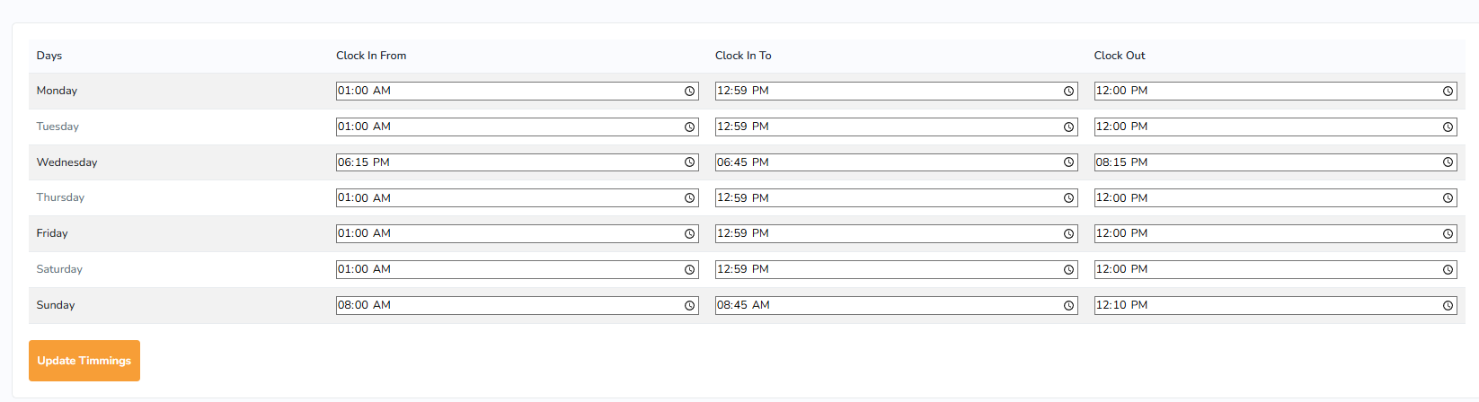

- EMPLOYEE users are presented with these options when clocking in and out. This is the ONLY screen EMPLOYEES can access
  - A clocked-in employee cannot CLOCKIN again without clocking out
  - One can not CLOCKOUT if they are not clocked in
  - One can CLOCKIN and CLOCKOUT twice in one day
  - One can CLOCKIN in one day and CLOCKOUT the next day (for late shifts)
  - The GUI should present these options and show remain on screen for 5 seconds after clocking in or out for verification, then auto logoff

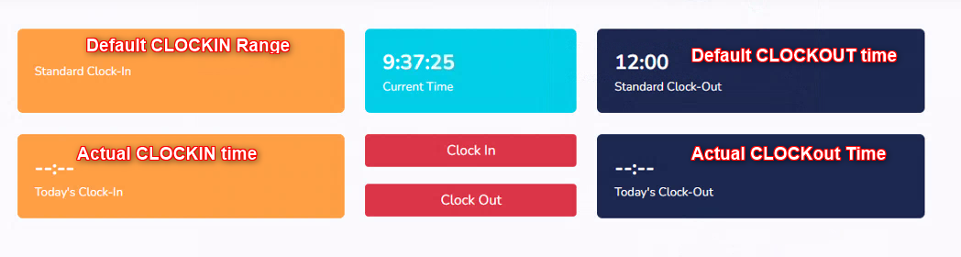
- There must be the ability to clone an existing employee profile to a new employee with the add function or create the new employee profile manually if Administrator desires.

- ADMINS should be able to see a screen like this so they can view all time records Additionally, they should be able to delete/add/update any records.
- Screen can be filtered by entering data into any FILTER FIELD
- Screen can be searched by name or date using SEARCH FIELD
- This screen should sort by clicking any of the filter field columns ascending and clicking
- again for descending
- This page should have an extract to CSV format function

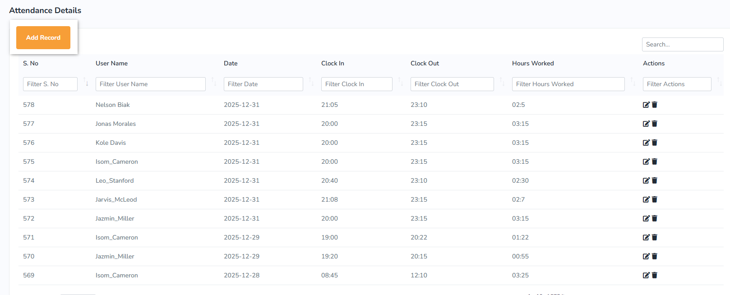

- AN ADMIN SCREEN that provides ability to add/update/delete users
- Screen can be searched by name or date using SEARCH FIELD
- If an employee is deleted all associated time records should also be deleted.

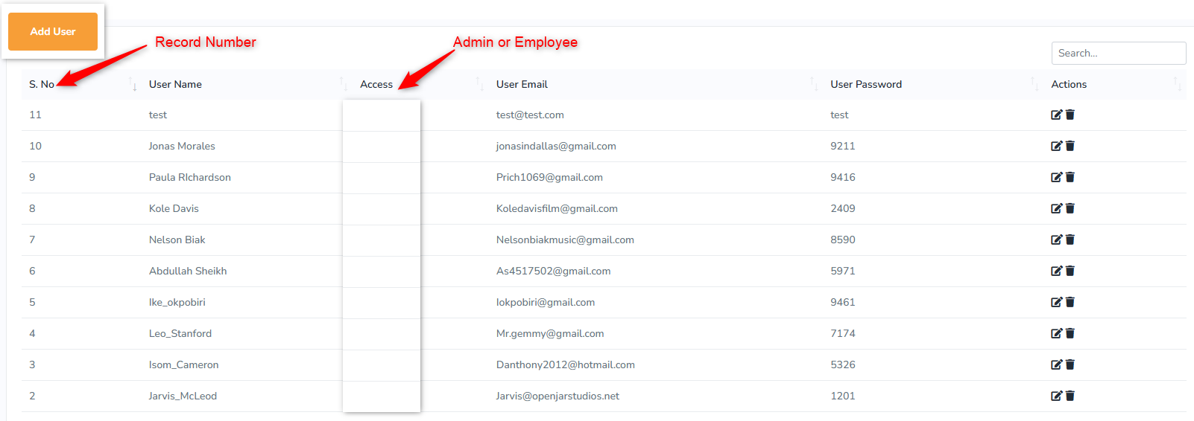

- A PAYROLL SCREEN that is created by filtering date range. The report will show the hours worked for dates within the date range filter and subtotals by name.

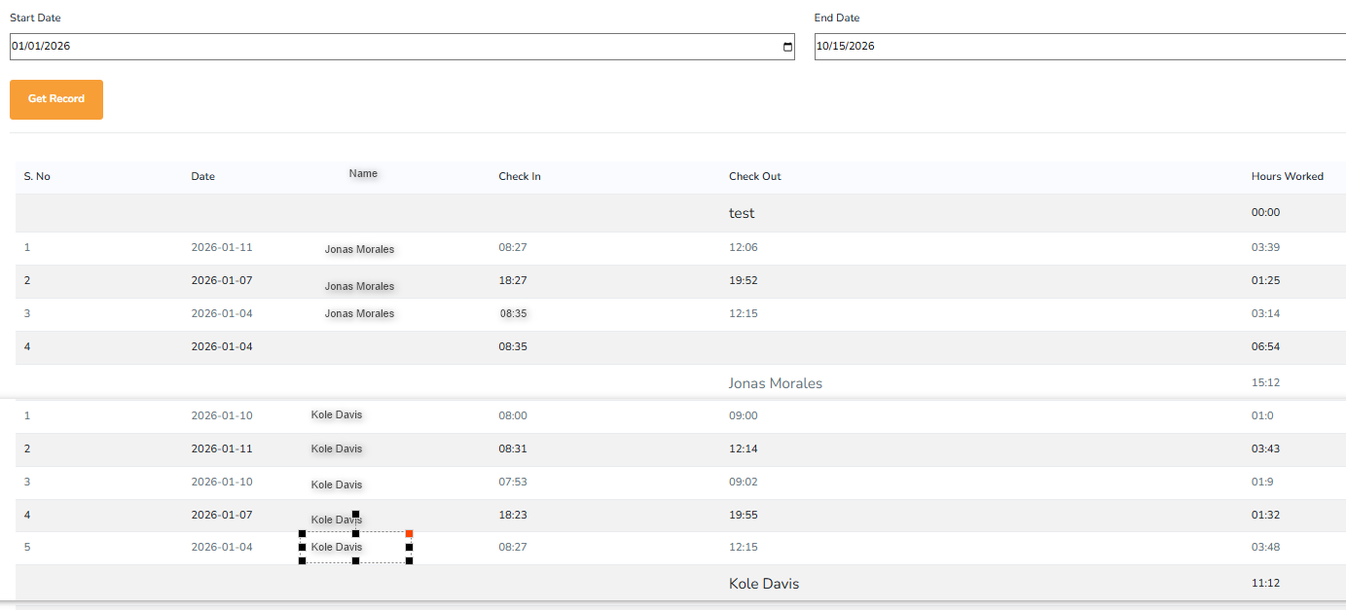

Manager Screen – This screen

- I need a simple intranet webpage that allows mangers to see who is clocked in at the present date/time.

Workers Currently Clocked In

Name Clock In Time
Emp Name 1 08:35
Emp Name 2 08:30
Emp Name 3 08:40

